Welcome to the
Bergthaler Mennonite Church
of Altona

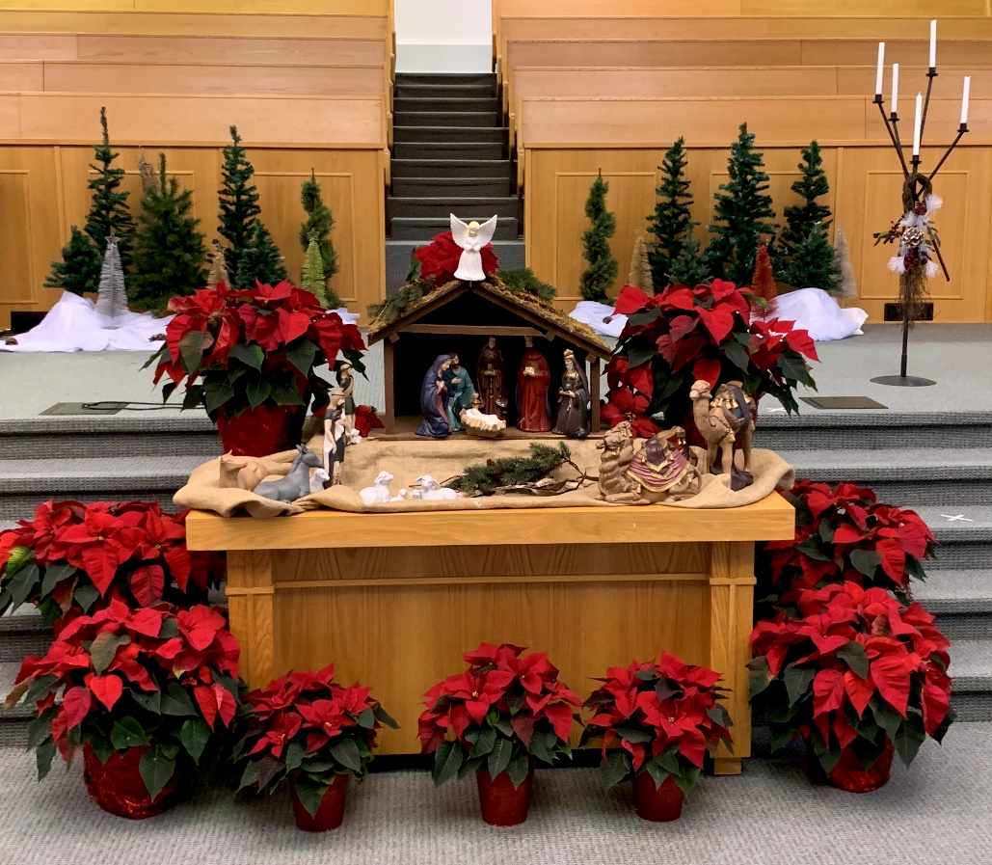
Photo credit: Susan M Dueck

Sunday, December 26, 2021

Bergthaler Mennonite Church of Altona

Worship Service

December 26 2021 10:30 A.M.

“A Savior has been born in David’s city, a Savior who is Messiah and Lord.” ~ Luke 2:11

REJOICING
Prelude
Welcome and Call to Worship
Candle lighting and Prayer
Hymn Oh, how joyfully HWB 209

LISTENING
Scripture Luke 2:1-7
Hymn Away in a manger HWB 194
Time with our children
Hymn To us a Child of hope is born HWB 189
Reflection Immanuel, God is with us
Hymn Infant holy, Infant lowly HWB 206
Scripture Luke 2:8-20
Reflection God’s vision revealed through the shepherds

RESPONDING
Hymn Good Christian friends, rejoice HWB 210
Prayer for the Church, the World and Offering
Blessing
Hymn Joy to the world HWB 318

Sermon: Virginia Gerbrandt Richert Worship Leader: Josh Janzen
Music: Tena Giesbrecht Candle Lighter & Scripture: Susan Dueck

Our worship service will be live-streamed Sunday morning at 10:30am and is available on the church website at [abchurchcommunity.ca]. If using a handheld device [phone/tablet] you may get a message that says “video unavailable”, but if you click on the line “watch this video on YouTube” it will reload and play for you.

PRAYER & PRAISE CORNER

~ Hospitalized: Katherine Bergen, Lena Hoffman, Harold Sawatzky, and Helen Schulz at Altona Health Centre.
~ Pray for Glenn Friesen as he’s receiving chemo treatments.
~ We would like to thank everyone for their thoughtfulness to us at the recent death of son Don Enns. We appreciated the many acts of kindness, visits, flowers, food, cards, phone calls, and hugs. We will miss him more than words can express, but by faith and prayers, we know we will see him again. With love and gratitude, Trudy Enns and family.
~ Mennonite Church Canada
Pray: Pray for PeaceBuilders Community and Lakan and Lakambini (Witness workers in the Philippines) as they deal with the aftermath of the Supertyphoon Rai (Odette). Communities in northern Mindanao were hardest hit. In initial reports we know that Pantojas are fine and that the partners who they are working with are also safe.

“Jesus it’s nice to meet you!”

Our Advent and Christmas worship series is all about
getting to know Jesus.

Nov 28 When and where did Jesus live? What was the context of Jesus
life and time?
Dec 5 What did Jesus teach? What was the essence of his message?
Dec 12 Speaker: Virginia What did Jesus do? And what did it
accomplish? What was it about?
Dec 19 Speaker: Mark Why did Jesus encounter opposition to his
message and work?
Dec 24 Christmas Eve Service of Lessons and Carols at 6:30pm.
Dec 26 Speaker: Virginia Baby Jesus.
Jan 2 Speaker: Mark 4 Gospels, 1 Jesus. How we learn about Jesus.
Jan 9 Speaker: Josh Who is Jesus?

CANDLE LITANY:

Leader: We light the Christ Candle and we welcome new life.
People: Hurry, hurry, sing the glory!
Imagine that... we are God’s wonders,
Blessed wonder

From the Pastor:

What is Sacred, Christmas Prayer
God, I approach this Christmas season with some trepidation, and a lot of fear and trembling.
Because I don't know if I really understood before, what was really sacred, before now. All the pomp and circumstance of Christmas lies by the wayside now, like crumpled wrapping paper.
After all, we are not here to impress anybody.
What is left, is the Christ Candle, burning the conviction into our hearts, that life is sacred, precisely because it is all so unique and beautiful and brief.
The fact that a young girl, a shepherd and a magi could each magnify God in their own, and yet important way makes me want to cry silent tears at the magnitude of the meaning of Christmas
So here we are... Fill us up, with what Christmas means for each of this year
Reminding us that God sent a baby in a manger for each and every one of us and God values us-- enough to send babies and angels and teachers and doctors and nurses and vaccines and masks and phone calls and cards and candles and stars and every other symbol that we need to remind us that we are beloved.
And that we are here to fill the world with love any way we can, because that is the Christmas miracle turning emptiness into something else.
Let us Go, and be comforted by the Love of God. May God Bless you and Keep you in Belovedness-- wrapped in the miracle that God is here.
Amen.
Always, forever,
God is even now. Here.
Alleluia.
Amen.

By Pastor Katy Stenta of katyandtheword.com

Bergthaler Mennonite Church of Altona 117 2ND Street NW Altona, MB R0G 0B1
Web Page Address: abchurchcommunity.ca Office: 324-6717 E-mail: office@abchurch.ca
Worship Services available online at: abchurchcommunity.ca Facebook: ABC community
Lead Pastor: Mark Tiessen-Dyck, 324-5990 cell 1-204-771-3406 marktd@abchurch.ca
Assoc Pastor: Virginia Gerbrandt Richert, cell 304-6119 virginiagr@abchurch.ca
Assoc Pastor of Youth Min: Josh Janzen, 204-502-1991, cell 1-402-631-3481 joshj@abchurch.ca
Children’s Ministry Coordinator: Amanda Wiens, 324-6719 amandaw@abchurch.ca

CHURCH ANNOUNCEMENTS

The position of Church Treasurer is a part-time appointed position with
duties and responsibilities related to the finances of the church, staff,
and the Canada Revenue Agency. A job description is available from any
member of the Finance and Maintenance Commission, and the church
office. If you have any questions re the above opportunity or
suggestions for a replacement, we encourage you to contact one of the
following members of the Finance Commission: Elmer Friesen, Al Harder,
Clint Klassen, and Al Friesen, Chair.

- Beginning early in the new year, we are going to be including people’s birthdays and significant wedding anniversaries in our weekly bulletin. This is a small way to build community and relationships, as we have the opportunity to wish one another a happy birthday. The church office is continuing to gather information and will be reaching out by email if we do not have your birthday and anniversary in our records. We look forward to celebrating one another in this way.

- Deadline for year-end donations is December 31st at noon. Donations can be dropped off at the church office. Any donations received after noon on December 31st will be receipted for 2022.

- The pastors will be taking some time off over the Christmas holidays: Mark will be on vacation Dec 25-27 and Jan 3-10 (He will be in the office Dec 28-31). Virginia will be on vacation Dec 27 - Jan 3.

- The Mitten Tree Project donations will be collected until January 2nd. All items collected will be donated to Union Gospel Mission in Winnipeg. If you are unable to bring your items to church, call Amanda Wiens 204-324-6719 to arrange for a pick-up.

- We are requiring that all 12 and over attending our in-person worship services be vaccinated. Please be willing to show your proof of vaccination. Wear masks throughout the worship service.

COMMUNITY ANNOUNCEMENTS

Mennonite Church Canada – office@mennonitechurchcanada.ca
Mennonite Church Manitoba – mennochurch.mb.ca 204-896-1616
- Woven Knowing Circle - Wednesday, December 29th from 8-8:45PM. Invite a friend, wrap your hands around a cup of something warm, have your journal ready...take some space to pause and reflect on the beginnings and endings of 2021, on where you are at this moment, and dream about what you want to be intentional about in the year ahead. Zoom link: https://us02web.zoom.us/j/2048961616
- Collecting stories of people's experiences with Spiritual Direction. If you are interested in participating in this project, please contact Laura Funk, Spiritual Director in Residence at Mennonite Church Manitoba. LFunk@mennochurch.mb.ca

Canadian Mennonite University – cmu.ca
- On behalf of the students, faculty, and staff we thank you for assisting CMU in promoting our programs and activities in your church. We do not take for granted the time and “ink” used to assist CMU in furthering its mission. Thank you for being a part of an incredible network of churches across Canada that continues to support our work of forming lives for service, leadership, and reconciliation. We wish you a blessed and joyful Christmas season!
MCC Manitoba - manitoba@mccmb.ca
- Merry Christmas from MCC! May you find joy, hope and new growth in Christ this Christmas season and in the coming year.
- A wide variety of SALT positions are now available! SALT is a 1-year cross-cultural service experience for Christian young adults from Canada and the USA. Explore international opportunities in fields such as education, agriculture, healthcare, community development and more! Visit mccmb.ca/salt for more information.

Mennonite Disaster Service – mdscanada@mds.org
- The Dec edition of On the Level is available from MDS. In this issue: MDS responds to the deadly tornadoes in the Midwest/ South USA, MDS Canada needs volunteers to help survivors recover from extensive flooding in British Columbia, and learn about our Annual Celebration in Sarasota, Florida in January. Go to https://conta.cc/3pTuFRA .

